Solution Design Document for Oracle Recruiting Cloud (ORC)

HCM SDD ORC [V2] and Date [20th Feb 2024]

Change Record

|  |  |  |  |
| --- | --- | --- | --- |
| Version No. | Date | Amendment History | Remarks |
| **1.0** | 21st  August 2023 | Initial Release |  |
| **1.1** | 7th December 2023 | After CRP1 |  |
| **2.0** | 20th February 2024 | After CRP2 |  |
|  |  |  |  |

Review

|  |  |
| --- | --- |
| Name. | Position |
|  |  |
|  |  |
|  |  |
|  |  |

1. **Title, Subject, Last Updated Date, Reference Number**, **and** **Version** are marked by a Word Bookmark so that they can be easily reproduced in the header and footer of documents. When you change any of these values, be careful not to accidentally delete the bookmark. **You can make bookmarks visible by selecting the Office Button>Word Options>Advanced> and checking the Show bookmarks option in the Show document content region.**
2. **Title, Subject, Last Updated Date, Reference Number**, **and** **Version** are marked by a Word Bookmark so that they can be easily reproduced in the header and footer of documents. When you change any of these values, be careful not to accidentally delete the bookmark. **You can make bookmarks visible by selecting the Office Button>Word Options>Advanced> and checking the Show bookmarks option in the Show document content region.**

Table of Contents

1 Introduction 3

1.1 Purpose 3

1.2 Document Scope 3

2 Recruiting Process 4

2.1 Process Step Description 4

2.2 Creation of Requisition 5

2.2.1 Requisition Creation Process 6

2.2.2 Manage Job Requisition 11

2.3 Candidate Application 11

2.3.1 Subscription for Talent Community by candidate 11

2.3.2 Candidate Creation – Add Candidate manually by Recruiter/Agency 12

2.3.3 Candidate Application by Employee via Internal Job Portal. 13

2.3.4 Candidate Application by Candidate (External career site) 15

2.3.5 Campaign Management 16

2.3.6 Candidate Application by Recruiter & Agency 16

2.3.7 Career Site Field Requirement Details 18

2.4 Manage Candidate Application 20

2.4.1 Manage Candidate Selection Process 21

2.4.2 Process Description 21

2.4.3 Manage Interview 21

2.4.4 Update and Cancel Interview Process 22

2.4.5 Interview Feedback Form 24

2.4.6 Manage Job Offer 25

2.5 Job Offer Letter Templates 28

2.6 Move to HR 29

3 Access and Approval Matrix 29

4 Onboarding 30

5 Open Action and Decision Points 31

6 Sign Off Sheet 32

# Introduction

The recruitment process includes working with requisitions and tracking applicant information. You enter a requisition to begin the process of filling a vacancy within the organization. A requisition is a record or document that contains information about the open position (an employee assignment for a fiscal year) and job description (the duties that an employee performs for the organization).

This document provides with Requisition Management, Candidate Management, Offer Process, and other requirements along with Fit gap analysis section.

## Purpose

The purpose of this document is to describe the key business structural elements that affect subsequent set up of the application. This deliverable is used to assist in the development of application setup. It includes:

* Requisition Process
* Candidate Management
* Offer Process
* Open and Closed Points

Recruiters and hiring managers use the Hiring work area to hire new employees and for internal mobility.

## Document Scope

This document contains the solution design and process as per the initial requirement gathering sessions. The below is not the part of this solution design document:

* Training Manuals
* Integration Design Document
* Test Scripts

This section provides the below details as per recruiting structure:

* Job requisition management
* Hiring management
* Candidate management
* Candidate job application management
* Job Offer management
* Agency and Agent management
* Campaign management
* Talent Community
* CRP Decisions
* Open and Closed Points

This document will cover all process flows in detail in the following section. Along with other subjects of the solution individually.

# Recruiting Process



## Process Step Description

|  |  |  |
| --- | --- | --- |
| **Steps** | **Step Name** | **Process Description** |
| **01** | **Requisition Creation** | Requisition Creation is a shared process between Hiring manager and Recruiter, wherein Hiring Manager can create a requisition using Position and will save the requisition. The Recruiter will receive the Notification to review the details, update the requisition and submit the requisition for an approval.  Organization will be defaulted based on position. |
| **02** | **Job Formatting** | In this step the Recruiter can add “Employer Description” and “Recruiting Organization Description” and “Media” links if any. |
| **03** | **Posting** | Recruiter can select the Job Boards on which recruiter will post the requisition. Example internal and external job boards, Agencies, or other job board like LinkedIn. Recruiter can also select agents to submit the candidate. |
| **04** | **Candidate Job Application** | 1. In Candidate Job Application Recruiter can create new candidate and submit their Job Application to any requisition. 2. Agency can submit the Candidate against the Invited Requisitions 3. External and Internal candidate can fill the job application and submit the same. |
| **05** | **Candidate selection Process** | Candidate selection process is a process where candidate must go through some Stages to get hired like Inbox, Screening, 1st Interview, Second Interview, Offer, HR etc. Few stages can be skipped as all stages are not mandatory. |
| **06** | **Offer process** | In this Process, Offer Letter is generated based on details filled in the Offer Page and same will be sent for an Approval. Once Approved the Offer can be extended to the candidate for Acceptance |
| **07** | **Pre-Onboarding Process** | Recruiter will move candidate to HR and Pre-Onboarding checklist will get triggered and candidate will get converted to pending worker. |
| **08** | **Hire** | On-boarding team will convert the Pending working to Employee. Onboarding checklist will get triggered as soon as the candidate is converted as an employee |

## Creation of Requisition

A Requisition is a document that describe all the details required to capture a human resource need in the organization. In ORC the requisition form is a standard form which covers all the aspect of the requisition fields.

The requisition process is as follows

* Hiring manager will raise a requisition, save, and close it.
* Recruiter will receive a notification to review the requisition and submit for an approval.

Once it is approved, Recruiter will receive the notification to do the job formatting and will post on career site, job boards.

### Requisition Creation Process

#### Process Description

The above flow shows a process flow diagram to Create Job requisition in the system. Job Requisition will be created by Hiring manager/Recruiter. In case Job Requisition is already created and need an update only same can be done from the same page by searching the Job requisition to be updated.

* **Process Input**

Information on Job Requisition such as:

* How
* Basic Info
* Requisition Structure
* Hiring Team
* Details
* Posting Description
* Offer Info
* Attachments
* Configuration (To be Filled by Recruiter)
* Questionnaires (To be filled by recruiter)
* **Process Output**

Upon Approval, Recruiter will be able to Post the new Job Requisition on different Job boards.

***\* Note*** *: - In case Recruiter has any further clarification they can use Send Message option to communicate with Hiring Team*

#### Process Step Description

|  |  |  |
| --- | --- | --- |
| Process Step | Process Description | Process Type |
| CA_JR_01 | Hiring Manager will Create new Job Requisition. | System |
| CA_JR_02 | To create new Job requisition Hiring Manager will Initiate the Job requisition request by using Position | System |
| CA_JR_03 | Enter the Job Requisition details | System |
| CA_JR_04 | Hiring Manager will save the requisition | System |
| CA_JR_05 | Recruiter will receive the notification | System |
| CA_JR_06 | Recruiter will Review and update the requisition details. | System |
| CA_JR_07 | Recruiter can Save & Close, Submit and cancel the requisition | System |
| CA_JR_08 | Recruiter will submit the transaction for approval. Once transaction is submitted, it is routed for approval process as per the approval matrix defined in the system | System |
| CA_JR_08.1 | Once Job Requisition is approved Recruiter will add interview template. | Manual |
| CA_JR_08.2 | Recruiter will add questionnaire. | Manual |
| CA_JR_08.3 | Recruiter will do the job formatting. Employer description based on different countries and legal employer can done based on positions. | Manual |
| CA_JR_08.4 | Recruiter will then post job requisitions on Internal/External career sites, job boards like LinkedIn, Naukri etc. or recruiter can invite agency to submit the candidates. | Manual |

#### Requisition Fields

Requisition Form: In following requisition form with the fields will be created. The same will be used by Hiring Managers and Recruiters to fill the requisition form

|  |  |  |  |  |  |
| --- | --- | --- | --- | --- | --- |
| Block Name | Name of Fields | Type of Field | Values | Mandatory | Comment |
| **How Section** | | | | | |
| How | Requisition Type | Pre-filled | * Standard | No |  |
| How | Use | Drop Down | * Position * Existing Requisition | Yes |  |
| How | Business Unit | Drop Down | Business Unit List | Yes | On Selection of Position |
| How | Position | Drop Down | List of all Positions | Yes | Position list will be visible based on persons position hierarchy |
| **Basic Information** | | | | | |
| Basic Information | Requisition Type | Pre-filled | Standard |  | Read Only Field |
| Basic Information | Requisition Title | Pre-filled | By Default, Position Name will be visible here | No |  |
| Basic Information | Number of Openings (Limited) | Pre-filled | A validation to be added on requisition creation to validate the open headcount available against the position | Yes | Defaulting from position headcount.  Read only field |
| Basic Information | Position | Pre-filled | Position Name | No | Read Only Field |
| Basic Information | Languages | LOV |  | No | Feasibility |
| **Hiring Team** | | | | | |
| Hiring Team | Hiring Manager | Drop Down | List of all Active Employees | Yes | Person name will be populated here who is raising the Requisition, however this is editable field |
| Hiring Team | Recruiter | Drop Down | List of all Active Employees (select recruiter name as advised in note) | Yes | Based on AOR assigned to the Recruiters Smart List of Values can be displayed with Recruiter Name, however user can search for all employee |
| Hiring Team | Add Collaborator Type | Drop Down |  | No |  |
| **Requisition Structure** | | | | | |
| Requisition Structure | Recruiting Type | Drop Down | * Graduate Trainee * Bahraini * Expat * DPC * Executive * Contingent worker | Yes | On Selection of Position |
| Requisition Structure | Primary Location | Defaulted | Pre-filled | Yes |  |
| Requisition Structure | Organization | Defaulted | Pre-filled | Yes |  |
| **Details** | | | | | |
| Details | Worker Type | Drop Down | * Contingent * Employee | Yes |  |
| Details | Regular or Temporary | Defaulted | Read only | No |  |
| Details | Full Time or Part Time | Defaulted | Read only | No |  |
| Details | Education Level | LOV | List of education levels. | No |  |
| **Posting Description (Visible to HM and Recruiter)** | | | | | |
| Posting Description | Internal Posting Description | Custom Box | * Short Description for Internal Candidates * Description for Internal Candidates * Responsibilities for Internal Candidates * Qualifications for Internal Candidates | No |  |
| Posting Description | External Posting Description | Custom Box | * Short Description for External Candidates * Description for External Candidates * Responsibilities for External Candidates * Qualifications for External Candidates | Yes |  |
| **Offer Information (Visible to HM and Recruiter)** | | | | | |
| Offer Info | Legal Employer | Drop Down | Legal Employers Name | Yes | Information will be defaulted based on Hiring Manager Assignment and values defaulted from Position |
| Offer Info | Business Unit | Pre-filled | Business Units Name | Yes |
| Offer Info | Department | Drop Down | List of Departments | Yes |
| Offer Info | Primary Location | Drop Down | All Locations Name | Yes |
| Offer Info | Other Work Location | Drop Down | All Locations Name | No |
| Offer Info | Job | Prefilled |  | No |  |
| **(Attachment Section)** | | | | | |
| Attachments |  | Drag and drop |  | No |  |
| **Configuration (Visible to Recruiter)** | | | | | |
| Configuration | Candidate Selection Process | Drop Down | * Staff Selection Process * DPC Selection Process | Yes |  |
| Configuration | External Application Flow | Drop Down | JAF | Yes |  |
| Configuration | Allow Candidates to Apply When Not Posted | Drop Down | * Yes * No | No |  |
| Configuration | Automatically Fill Requisition | Drop Down | * Yes * No | No |  |
| **Questionnaire (Visible to Recruiter only)** | | | | | |
| Questionnaire |  | List of Questions | * Pre-screening Questionnaire of External Candidate * Pre-screening Questionnaire of Internal Candidate * Interview Feedback Questionnaire | Yes |  |

### Manage Job Requisition

Once the job is posted to the career sites, recruiter will have full control on the postings. Following are the actions which recruiter can do to manage the job posting

* Fill Job Requisition
* Preview Job Requisition
* Suspend Job Requisition
* Cancel Job Requisition

## Candidate Application

Candidate application flow is a sequence of pages that must be completed by a candidate when applying for a job or when submitting a profile on a Career Section. A candidate can also be matched to a requisition directly by the owners of the requisition.

### Subscription for Talent Community by candidate

#### Process Description

The above flow shows a process flow diagram to subscribe the talent community when candidate doesn’t find any suitable job.

* **Process Input**
* Information to Create Candidate such as:
* Candidate Details
* Document Attachment (If Any)
* **Process Output**
* New Candidate will be created in system.

#### Process Step Description

|  |  |  |
| --- | --- | --- |
| Process Step | Process Description | Process Type |
| **CA_01_TC** | Requisition is posted on career site ref. CA_JR_11 | System |
| **CA_01_TC.1** | In case the candidate doesn’t find any job posted matching his profile, candidate can subscribe to Talent Community | System |
| **CA_01_TC.2** | To subscribe to Talent Community candidate will enter the Email Id. | System |
| **CA_01_TC.3** | Candidate must enter details manually. | System |
| **CA_01_TC.4** | After entering details candidate will click on subscribe. | System |
| **CA_01_TC.5** | Email Verification will be done by sending Verification code to candidate’s email id | System |
| **CA_01_TC.6** | Candidate will get created in the Global Talent Community Pool | System |

### Candidate Creation – Add Candidate manually by Recruiter/Agency

#### Process Description

The above flow shows a process flow diagram to add candidate manually by Recruiter / Agency.

**Process Input**

Information to Create Candidate such as:

* Candidate Details
* Document Attachment (If Any)

**Process Output**

New Candidate will be created in system.

#### Process Step Description

|  |  |  |
| --- | --- | --- |
| Process Step | Process Description | Process Type |
| **CA_RA_01.1** | To create new candidate, Initiator can add the candidates in their respective Candidate pools (Here Initiators are Recruiter & Agency) | System |
| **CA_RA_01.2** | Initiator will enter the basic details and can upload the attachments | System |
| **CA_RA_01.3** | Initiator will save and close the page | System |
| **CA_RA_01.4** | Initiator will get confirmation message asking to add more details of candidate or exit the page | Manual |
| **CA_RA_01.5** | In case Initiator decides to continue with the decision, will add more details in the profile.  In case Initiator decides to continue without addition of any further details, the process gets completed with the basic details provided | System |

### Candidate Application by Employee via Internal Job Portal.

#### Process Description

The above flow shows a process flow diagram to search for the job from internal career portal and submit the job application by Employee.

**Process Input**

Information for Job Application such as:

* Candidate Personal Information
* Candidate Profile data
* Add Attachment if any

**Process Output**

After completion of the process New Job Application will be created into the system

#### Process Step Description

|  |  |  |
| --- | --- | --- |
| Process Step | Process Description | Process Type |
| **CA_IC_01** | Requisition is posted on job boards. Ref.- CA_JR_11.1 | System |
| **CA_IC_02** | Employee will search and select the Job Requisition | System |
| **CA_IC_03** | Employee can either apply for the job or copy and share the link to others or can cancel the entire process. | System |
| **CA_IC_03.1** | If employee applies for the job application, he will fill the job application questions. | System |
| **CA_IC_03.1.1** | Employee will attach supporting documents like CV mandatorily. | System |
| **CA_IC_03.1.2** | Employee will enter full name as E-Signature. | System |
| **CA_IC_03.1.3** | Employee can review and update skills and qualifications. | System |
| **CA_IC_03.1.4** | Employee will submit the transaction. | System |
| **CA_IC_03.1.5** | Once employee submits the transaction, application will be created. |  |
| **CA_IC_03.1.6** | Employee will receive the Confirmation message | System |

### Candidate Application by Candidate (External career site)

#### Process Description

The above flow shows a process flow diagram to search for the job from external career portal / LinkedIn and submit the job application by Candidate.

Candidate application flow is the forms and list of blocks that the candidate fills while applying for a job. For applying on a job, candidate follows the following flow

* If Candidate has already applied for Job Requisition, then he/she can withdraw the application anytime if candidate is no more interested.

**Process Input**

Information for Candidate Application such as:

* Candidate Personal Information
* Candidate Profile data
* Add Attachment if any

**Process Output**

After completion of the process New Job Application will be created into the system

#### Process Step Description

|  |  |  |
| --- | --- | --- |
| Process Step | Process Description | Process Type |
| **CA_EC_01** | Candidate will go to the job boards like External career site to apply for the vacancy. | System |
| **CA_EC_02** | Candidate will search & select the Job Requisition | System |
| **CA_EC_03** | Candidate can Apply the Job requisition or share the same with anyone. | System |
| **CA_EC_03.1** | Candidate can share and copy the link of the job requisition. | Manual |
| **CA_EC_03.2** | Candidate can choose to cancel the entire process by clicking on cancel. | System |
| **CA_EC_03.3** | To Apply for the Job Requisition candidate will enter the Email Id | System |
| **CA_EC_03.3.1** | Email Verification will be done by sending Verification code to email id | System |
| **CA_EC_03.3.2** | After verification Candidate will have to fill all required details and pre-screening questions | System |
| **CA_EC_03.3.3** | Candidate will upload supporting document like CV or miscellaneous document | System |
| **CA_EC_03.3.4** | Candidate will enter the E-signature(Candidates Full name). | System |
| **CA_EC_03.3.5** | Candidate will submit the transaction. | System |
| **CA_EC_03.3.6** | Application will be created once transaction is submitted | System |
| **CA_EC_03.3.7** | Candidate will receive the confirmation mail | System |

### Campaign Management

Social media posts can be created and managed with personalized landing pages as part of a Recruiting Campaign. This helps to widen the target audience of engaged candidates.

Using campaigning, we can post campaigns regarding open positions and requisitions and post them on social media or career sites and also send mass email to candidates in a single go.

To create a **Social Media Campaign**, users will:

1. Create a post and a landing page
2. Capture basic analytic metrics
3. Create the Recruiting Campaign, then select the **Social Media** tab on the left
4. Select the button in the upper right to ***+ Add***
5. On the **Posts** page, enter a name for the post
6. Select a channel for the post; possible options are:

**Facebook**

**Twitter**

**LinkedIn**

**Other**

1. Select a landing page, or create a new one
2. Enter a URL to add an image
3. Enter an external description for the landing page
4. Select a career site where the post will appear
5. Select the button to ***Save***

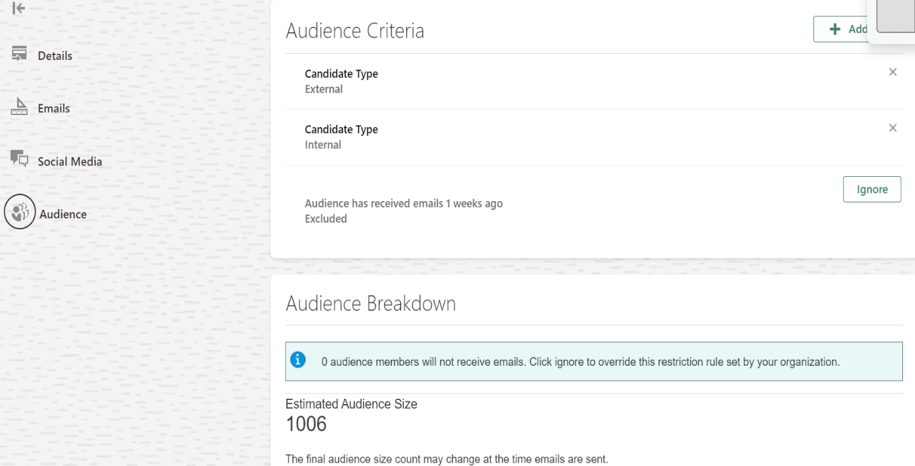

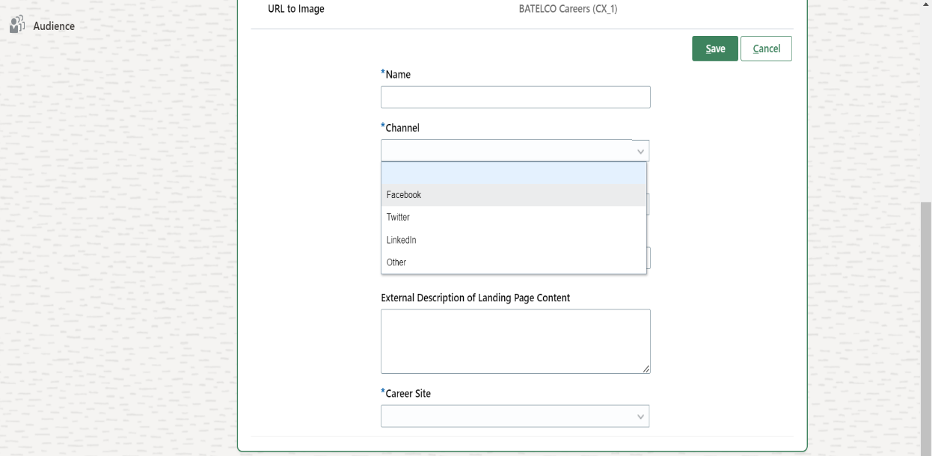

### Candidate Application by Recruiter & Agency

1. Diagram

   Description automatically generated

#### Process Description

The above flow shows a process flow diagram convert the candidate to applicant by adding the candidate to Job Requisition by Recruiter/Agency.

* Recruiter can perform various Actions once candidate is created in system like
* Add to Requisition – Add candidate to new Job requisition
* Add to Candidate Pool – Add candidate to any Candidate Pool for future reference
* Add Interaction - Recruiter can record all Interaction details
* Send Invite – Send invite to apply for job requisition
* Convert Prospect – Convert Prospect to Job Application
* Send Message – send message using Email id
* Update to not interested – Recruiter can update not interested in case candidate doesn’t want to apply for job and send a separate rejection email.
* Delete Prospect- Recruiter can delete the candidate

**Process Input**

Information for Candidate Application such as:

* Candidate Personal Information
* Candidate Profile data
* Add Attachment if any

**Process Output**

After completion of the process New Job Application will be created into the system

#### Process Step Description

|  |  |  |
| --- | --- | --- |
| Process Step | Process Description | Process Type |
| **CA_R_01** | Recruiter will select the candidate which is already created in system ref. **CA_01_TC** | System |
| **CA_R_02** | Once Candidate is selected, Recruiter will perform the action, **Add to requisition** | System |
| **CA_R_03** | Recruiter will select the Requisition | System |
| **CA_R_04** | Recruiter will have a checkbox option to create job application on behalf of candidate. | System |
| **CA_R_04.1** | If Recruiter checks the checkbox to create job application on behalf of candidate, candidate will be added as an applicant. |  |
| **CA_R_04.2** | If Recruiter doesn’t check the checkbox to create job application on behalf of candidate, candidate will be added as a prospect. |  |
| **CA_R_05** | Recruiter receives a confirmation message. |  |
| **CA_R_06** | If candidate is added as an applicant, candidate receives a “Provide Additional Info” Email. And if candidate is added as a prospect, candidate receives an Invitation Email. | Manual |
| **CA_A_01** | Agency will receive the Requisition Invitation posted by Recruiter, ref **CA_JR_11.3** | System |
| **CA_A_02** | Agency will Click on Submit Candidate Button to refer the candidate | System |
| **CA_A_03** | Agency will search the candidate created in Talent Pool, ref **CA_RA_01.1** | System |
| **CA_A_04** | Agency will select the candidate to be referred | System |
| **CA_A_05** | Once Candidate is selected Agency will submit the transaction | System |
| **CA_A_06** | Upon Submission the Prospect get created against the selected requisition | System |

### Career Site Field Requirement Details

The Career site fields will be used when the candidate will apply on a particular job. These are the series of fields using which we are asking candidate to provide his/her information (Personal, Educational, Work Experience)

The table below provides a detail about all the fields that would exist on the career section forms for the Career Portals

Candidate information will be captured in the standard form from ORC and the same information will be used for the candidate selection process.

|  |  |  |  |  |
| --- | --- | --- | --- | --- |
| Block Name | Name of Fields | Type of Field | Mandatory | Comment |
| Contact information | Last name | Free text | Yes |  |
| Contact information | First name | Free text | Yes |  |
| Contact information | Middle name | Free text | No |  |
| Contact information | Title | Drop down | No |  |
| Contact information | Phone number | Free text | Yes |  |
| Contact information | Email | Free Text | Yes |  |
| Contact information | Re-enter Email | Free Text | Yes |  |
| Contact information | Nationality | Drop down | Yes |  |
| Contact information | Gender | Drop down | Yes |  |
| Address | Country | Drop down | No |  |
| Address | Address line 1 | Free text | No |  |
|  |
| Address | Address line 2 | Free text | No |  |
| Address | PO Box | Free text | No |  |
| Application questions | List of questions preselected for the requisition | As per configuration of the questions mentioned | All questions mandatory |  |
| Experience | Employer Name | Text box | Yes |  |
| Experience | Job title | Text Box | No |  |
| Experience | Start Date | Drop Down | No |  |
| Experience | End Date | Drop down | No |  |
| Experience | Current Job | Checkbox | No |  |
| Experience | Additional Information | Text Box | No |  |
| Attachments |  |  | Yes | CV is mandatory to attach |
| E-signature | E-signature | Textbox | Yes |  |

## Manage Candidate Application

### Manage Candidate Selection Process

In selection process is to be implemented based on employee type

1.

2.

### Process Description

Candidate Selection Process is the selection process a candidate goes through before being selected.

### Manage Interview

##### Process Description

The above flow shows a process flow diagram to schedule an interview with candidate

##### Process Step Description

|  |  |  |
| --- | --- | --- |
| Process Step | Process Description | Process Type |
| CA_MI_01 | Candidate will be selected at the interview phase in Candidate Selection Process. | System |
| CA_MI_02 | To schedule an interview Recruiter will add the Interview Template for the candidate attached to the Job Requisition. | System |
| CA_MI_03 | Recruiter will enter the Interview details as per the Interview Template | System |
| CA_MI_04 | Recruiter will select the Interviewer and enter the details and save the form | System |
| CA_MI_05 | Notification will be sent to Interviewer and candidate | Manual |

### Update and Cancel Interview Process

##### Process Description

The above flow shows a process flow diagram to reschedule or cancel an interview with candidate

**Process Input**

Information for Manage Interview such as:

* Updated Interview details

**Process Output**

* Recruiter will reschedule or cancel an interview.

##### Process Step Description

|  |  |  |
| --- | --- | --- |
| Process Step | Process Description | Process Type |
| CA_IRC_01 | Recruiter will select the candidate | System |
| CA_IRC_02 | Recruiter will select the Scheduled Interview | System |
| CA_IRC_03 | Recruiter can either reschedule or cancel the interview. | Manual |
| CA_IRC_04 | Recruiter will update the interview details in case recruiter wants to Reschedule the interview | System |
| CA_IRC_05 | Recruiter will Submit the transaction | System |
| CA_IRC_06 | Notification will be sent to Interviewer and candidate in case of Reschedule or cancelation of Interview | System |

### Interview Feedback Form

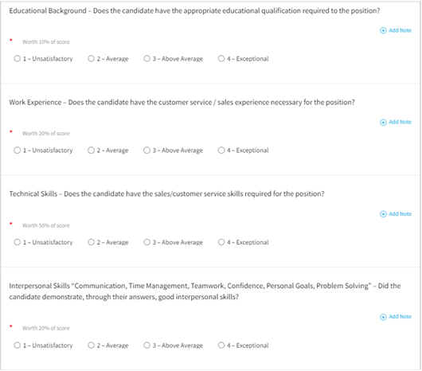

### Manage Job Offer

#### Process Description

The above flow shows a process flow diagram to generate Job Offer letter for candidates,

**Process Input**

Candidate Job Offer Details

**Process Output**

Job Offer Letter will be generated upon the offer accepted by Candidate

#### Process Step Description

|  |  |  |
| --- | --- | --- |
| Process Step | Process Description | Process Type |
| CA_JO_01 | Recruiter will receive the Application from candidate Application **Ref.- CA_01_TC** | System |
| CA_JO_02 | Recruiter will decide whether to consider candidate for job offer or not | Manual |
| CA_JO_02.1 | In case decision is yes Recruiter will create the Job Offer. | System |
| CA_JO_02.2 | To Create the Job Offer, Recruiter will Create the Job offer by filling the details | System |
| CA_JO_02.3 | Recruiter will select the Job Offer template from the drop-down option | System |
| CA_JO_02.3.1 | After filling all the details Recruiter will decide to Save & Close or submit the offer letter | Manual |
| CA_JO_02.3.1.1 | If recruiter save and closes the job offer, it will be saved as draft, and he can preview the job offer. |  |
| CA_JO_02.3.1.2 | Recruiter can edit the job offer by clicking on edit offer option. | System |
| CA_JO_02.3.1.3 | Recruiter will update the job offer details and again continue Ref- CA_JO_02.3.1 | System |
| CA_JO_02.3.2 | Approver will decide to Approve or Reject the transaction. | Manual |
| CA_JO_02.3.2.1 | In Case if the transaction is approved by all the stake holders, an approval confirmation will be sent to recruiter | System |
| CA_JO_02.3.2.2 | Once the offer is approved, the offer is extended to the candidate by recruiter | System |
| CA_JO_02.3.2.3 | Job Offer notification will be sent to the candidate | System |
| CA_JO_02.3.2.4 | Candidate will decide either to Accept or Reject the job offer | Manual |
| CA_JO_02.3.2.4.1 | In Case of acceptance Recruiter will receive the Job Offer Acceptance notification. And candidate will receive a notification to prepare all required document for pre joining process. | System |
| CA_JO_02.3.3 | If Transaction is rejected by Approver, then notification will be sent to Recruiter for further action. In Case recruiter wants to redraft the job offer please follow steps from **CJO_02.3.1.2** onwards. | System |
| CJO_02.3.2.4.2 | If Job Offer is declined by Candidate, then notification will be sent to recruiter for further action. | System |

#### Job Offer Fields

|  |  |  |  |  |
| --- | --- | --- | --- | --- |
| Section | Field Name | Field Type | Mandatory | Values |
| When and Why | When is the employee start date | Date | Y |  |
| When and Why | Legal Employer | Drop Down | Y | All list of Legal Entities, The default value will be from Requisition |
| When and Why | Action | Drop Down | Y | Add Pending Worker |
| When and Why | Worker type | Drop Down | Y | Employee |
| Assignment Info | Business Unit | Drop Down | Y | All list of Business Unit, The default value will be from Requisition |
| Assignment Info | Position | Drop Down | Y | All list of Position, The default value will be from Requisition |
| Assignment Info | Job | Defaulted text field | Y | Defaulted from Position |
| Assignment Info | Business title | Text box | Y |  |
| Assignment Info | Grade | Drop Down | Y |  |
| Assignment Info | Department | Drop Down | Y | Defaulted from Requisition |
| Assignment Info | Location | Drop Down | N | Defaulted from Requisition |
| Offer Team | Hiring manager | Drop Down | N | Defaulted |
| Offer Team | Recruiter | Drop Down | N | Defaulted |
| Offer Team | Add Collaborator type | Drop down | N |  |
| Salary | Salary Basis | Drop Down | Y |  |
| Salary | Salary Amount | Text Box | Y |  |
| Salary | Annual salary | Defaulted from salary Amount | N |  |
| Salary | Grade name | Defaulted | N |  |
| Salary | New Salary | Calculated from salary amount | N |  |
| Other Compensation | To be added |  |  |  |
| Comments & Attachments | Offer comments | Text box | N |  |
| Comments & Attachments | Internal Documents | Attach file here | N |  |
| Offer Letter | Offer Letter | Drop Down | N |  |
| Offer Letter | Expiration Date | Date | N |  |
| Offer Letter | Additional Text1 | Free text field | N | It can be used In case recruiter would like to add any addition details on Offer Letter |

## Job Offer Letter Templates

The job offer template required is as follows.

These are the offer letters provided as of yet, it is decided that the Medical and security letters will be sent to the candidate during the Pre-onboarding journey to the candidate.

    

## Move to HR

Once the candidate is moved to HR it will be converted as Pending Worker in System and it will be considered as Hired in Oracle Recruitment Cloud. Upon converting Candidate to Pending Worker, Pre-Boarding checklist will be triggered, and task will be assigned to the pending worker as defined in Checklist.

# Access and Approval Matrix

Following is the access and approval matrix for transactions:

The data is secured in Cloud using Data Security Profiles. There are different roles in Cloud which have access to different set of data and define which actions can be performed by which role.

# Onboarding

Following are the onboarding flows as discussed and requested during the HLA & CRP sessions.

The following checklist triggers after converting candidate from Pending worker to an Employee-

The below tasks will have the updated sequence as mentioned-

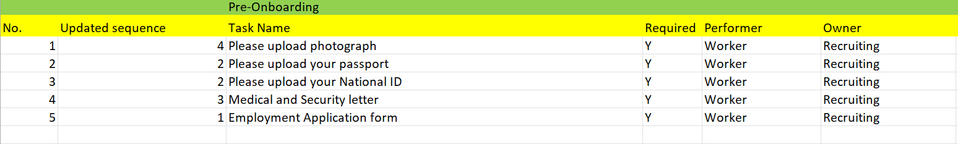

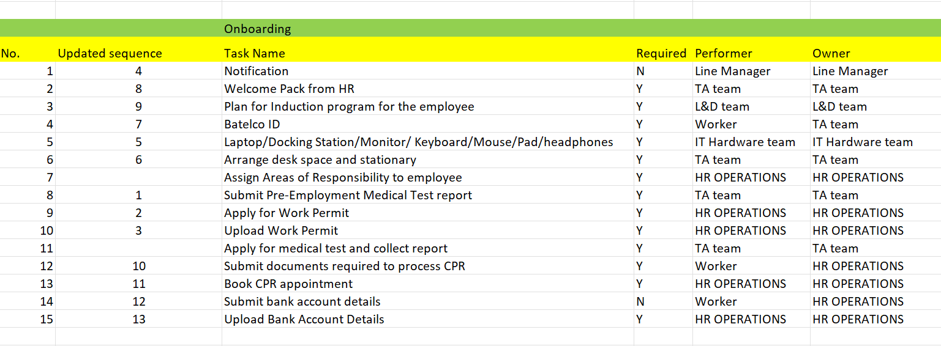

# Open Action and Decision Points

These points need to be cleared with utmost importance-

|  |  |  |  |
| --- | --- | --- | --- |
| # | Requirement/Issue | Remark | Assignee |
| 1 | Career portal design, Branding and demo. |  |  |
| 2. | Data migration of candidate pools. Template provided to . |  |  |
| 3 | Data migration for job profiles |  |  |
|  |  |  |  |
|  |  |  |  |

# Sign Off Sheet

|  |  |
| --- | --- |
| Project Name |  |
| Project Manager | Mr. Karan Sharma |
| Date |  |

Legend

* Yes (**Y**) response implies that the deliverable is approved.
* No (**N**) response implies that the deliverable is rejected with reasons and justification.
* Yes, with Notes (**YN**) response implies that the deliverable is approved with the required modification documented in that section.
* Remark: Stakeholder authorized personnel Sign-off shall not relieve the Vendor of his obligation to perform the work in accordance with the Contract document.

|  |  |  |
| --- | --- | --- |
| No | Description | Type |
| 1. | **ORC Implementation SDD Sign Off** | **Document** |
|  | | |

Stakeholders’ Approval

|  |  |  |  |  |
| --- | --- | --- | --- | --- |
| No. | Stakeholder Name | Group | Signature | Signed Off?  YES No |
|  |  |  |  |  |
|  |  |  |  |  |
|  |  |  |  |  |
|  |  |  |  |  |
|  |  |  |  |  |
| **YES, with the following notes** | | | | |

Signature

|  |  |  |
| --- | --- | --- |
|  |  | Date: |
|  |  | Date: |
|  | ____________________ | Date: |